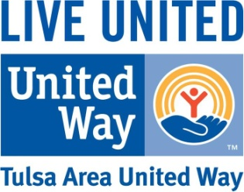
Leaders in Giving
Members List

Please complete and return this form by December 1st so all Leadership Givers & Tocqueville Society members may be recognized (unless noted Anonymous below). Please visit www.tauw.org to order recognition items for your members or get this form electronically. Remember these Leadership Giving pledges should also be included on your Campaign Report.
Division:
Date: Acct #:
Organization:
Campaign Coordinator & Phone:
Recognition Name | E-mail Address | Pledge  Amount  (Key Club begins at$500) | Payroll  Deduction (PD)  (Yes/No) | If not PD, payment method (CC/Check/  Bill Me) | Anon.  (Y/N)

Total Number of Members: _____________ Total Amount of Key Club Pledges: $ __________
(Please be sure that these Leadership Giving pledges are also included on your Campaign Report)

